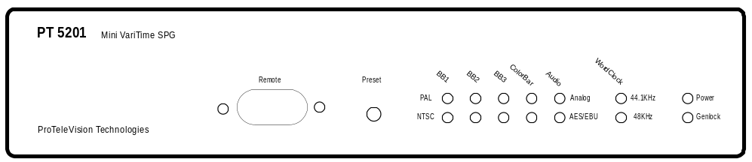With VaritimeTM features

- VariTimeTM, 8 fields for PAL  - VariTimeTM, 4 fields for NTSC  - Master applications with external high stability reference  - Genlock to PAL or NTSC Black Burst signals for slave applications  - Multistandard: 525/60, 625/50 and dual standard operation  - Outputs:  3xBlack Burst  1 Colorbar/ BlackBurst  1 SDI Colorbar/ Blackburst  1 AES/EBU or Analog Audio and WordClock  - Fully remote control, local indications for Power, System and Genlock  - Euro list price: EUR 1.990 excl. VAT and other local taxes – only EUR 497 per channel | Introduction  The new digital studios needs cost efficient and reliable synchronization for the main equipment to work reliable. For this purpose PTV offers a fully integrated solution eliminating any costs associated with modular structures, support of very many different signal types and fancy operating features.  With the PT5201 You pay only for the needs You have, all solutions have been carefully designed to meet all requirements for a modern, highly sophisticated digital product. PTV introduces this sync generator as the first of its type ever seen! The PT5201 out-performs any known sync generator available at the price level of PT5201. | Application  The target application for the PT5201 is primarily medium and large size TV production or post-production studios which has a high need for many high quality Black Burst synchronization signals. If more signals are needed than the four signals provided by the unit, more units can be daisy-chained to meet the need.  The PT5201 BlackBurstSync is ideal as a partner to PTV’s large program of sync & pattern generators. More sophisticated and flexible needs are covered by the PT5210 VariTimeTM Digital Sync Generator. The PT5201 meets the need of a large number of Black Burst channels for a lower per channel cost.  Associated products  SDI Black Sync, PT5202  TimeCodeGen, PT5203  DestribAmp, PT5205

Data Sheet
Electrical Specifications  Genlock:  - Input: 75Ω looped through  - Return loss: >36dB to 6MHz  - Genlocks to M-NTSC or G-PAL  - Amplitude nominal: ±3dB  - S/N Ratio: >26dB  - Sc-H phase nominal: ±45°  - Jitter when locked: <2ns  - Timing range PAL: ±4 fields  - Timing range NTSC: ±2 fields  - Timing resolution: 1° f_{SC}  Analog Black Burst Outputs:  - Connector: BNC  - Impedance: 75 Ω  - Return Loss: >36dB, to 5MHz  - Amplitude nominal: -300mV ±2%  - Timing range PAL: ±4 fields  - Timing range NTSC: ±2 fields  - Timing resolution: 1° f_{SC}  - Sc-H phase: default 0°, adjustment to ± 180°, resolution <5°  - S/N Ratio: 60dB unweighted to 5MHz  - Jitter: ± 0.5ns, locked to input | Analog Colorbar:  As PT8639  AES/EBU and WordClock:  As PT8605  Analog Audio Output:  SDI Colorbar/blackBurst Output:  As PT8639, but SDI  Interface  - Control interface: RS232.  -Connector:9 pole D, DTE –Protocol: SCPI based  - Indications:  - Front panel LED indicators for alarm, sync status and power.  - Power Supply: 90V - 250V,45 – 65Hz  - Power usage: max. 20VA  Mechanical Specifications  - Cabinet:  –Width: 217  –Height: 44 mm  –Depth: 280mm  - Weight: 1.5 kg  - Cooling:Convection  Accessories  - 19” Rack mounting kit, space for two PT5201 | Environmental Specifications  - Temperature range operating: 0°C – 50°C  - Temperature range within spec.: 5°C – 45°C  - Temperature range storage: -30°C - 70°C, under 0°C and over 50°C in max. 72 timer  - Warm-up time: <15 min.  - Humidity operating : max. 90% RH  - Humidity storage: max. 90% RH  EMC  Compliant to EN50081-1[3], EN50082-1 [4], EN50081-2 [5] and EN50082-2 [6]  FCC Rules & regulations, part 15, subpart J, level B (emission)  Safety  Compliant to IEC 1010 [7]

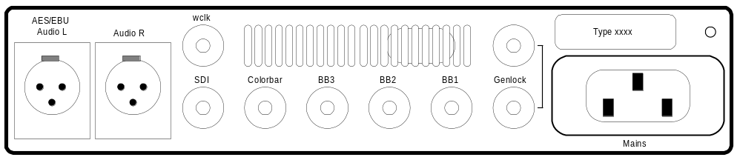Rear Panel Layout:

Ordering Information  PT 5201 9449 052 01001 BlackBurstSync  PTxxxx 9449 0xx xx001 Rack mounting kit | To order or for further information, contact the PTV sales office in your area. Or please contact us directly.  Ordering is on-line available 24 hours per day with our Web Site: www.ptv.dk

